Saturday Pack
Ama Infant
https://www.amazon.com/dp/B0H5BWNNR5?th=1&psc=1

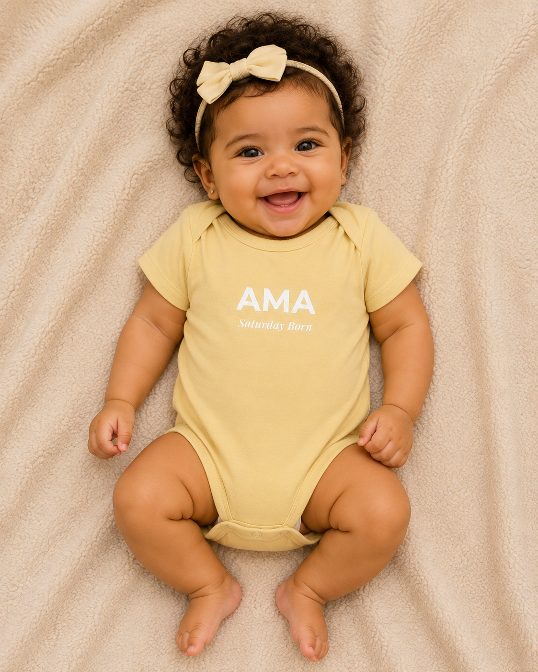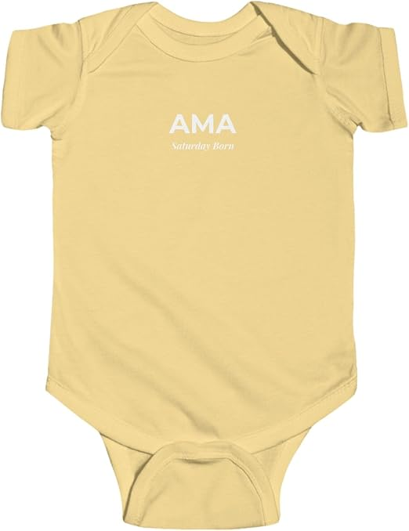
Kwame infant
https://www.amazon.com/dp/B0H5BSV45R?th=1&psc=1
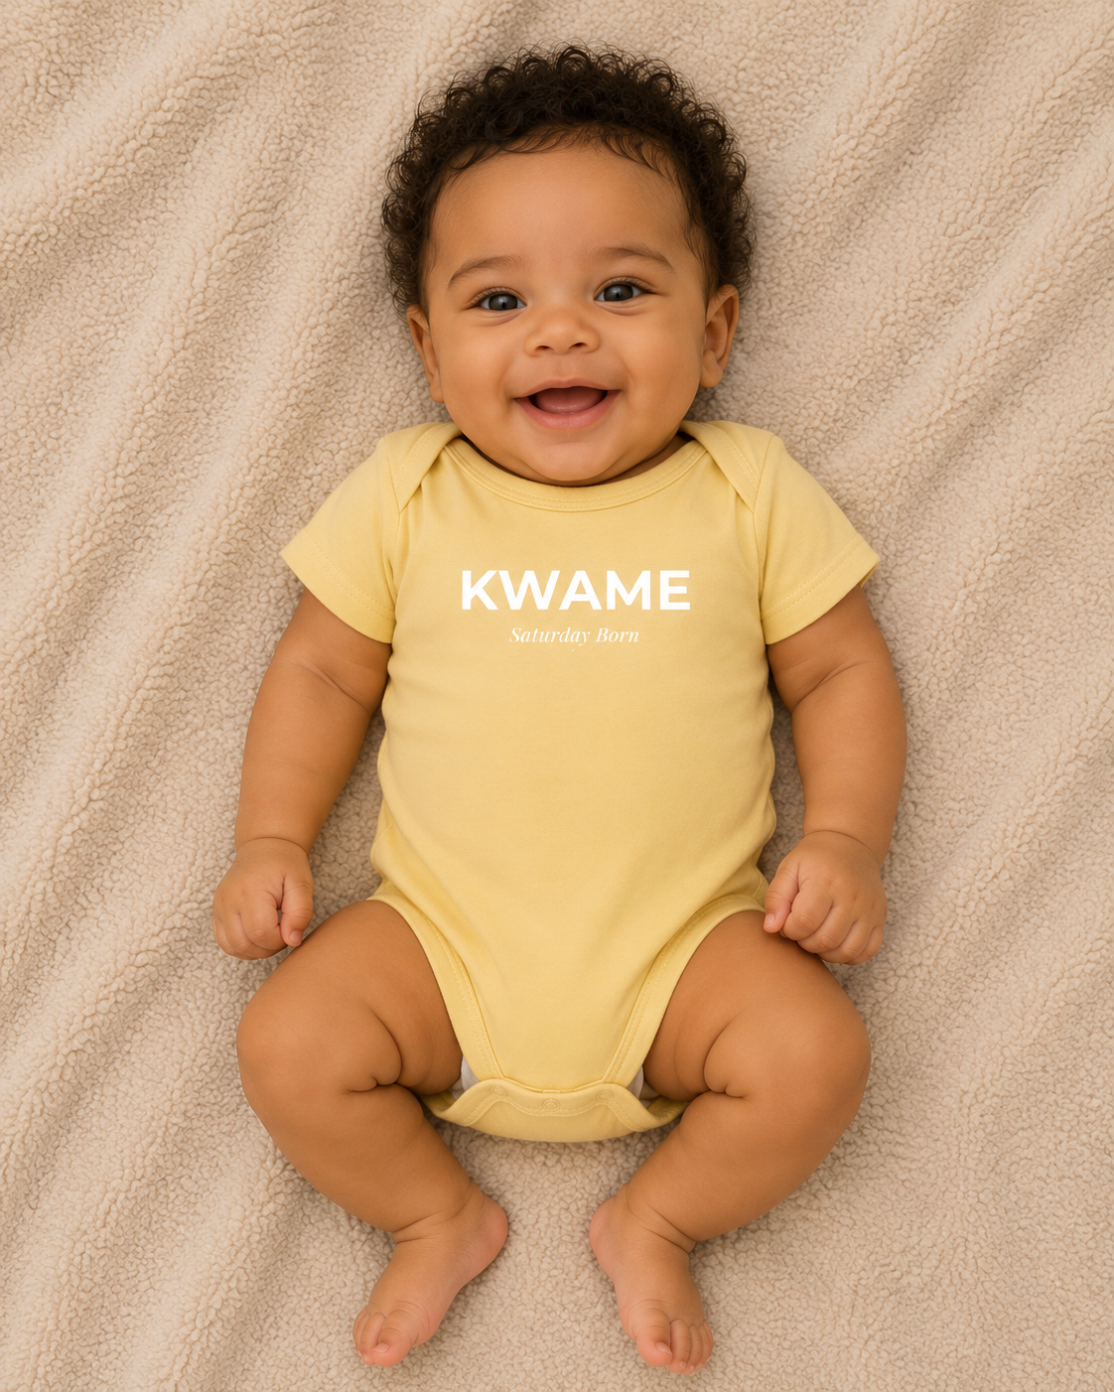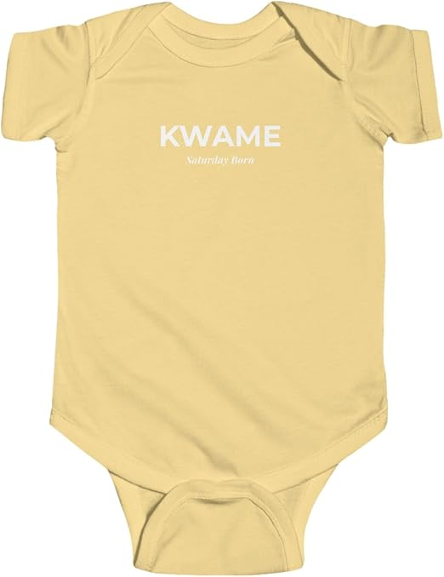

Kwame Gye Nyame Mug
https://www.amazon.com/dp/B0H5BR8FQ3
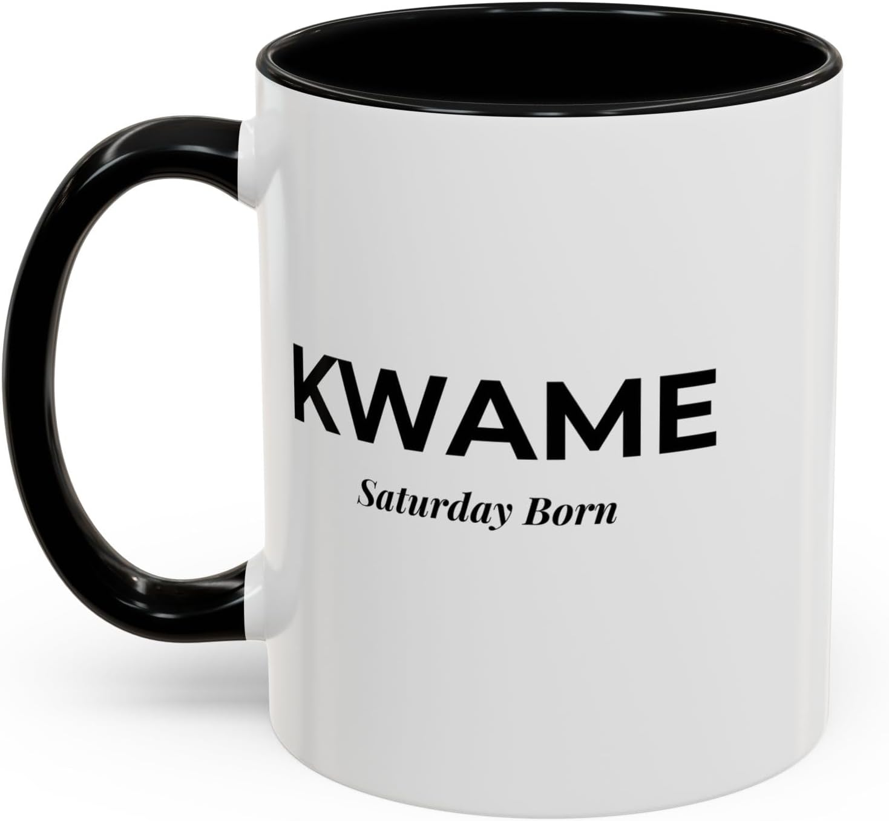
Kwame Sankofa Mug OUT OF STOCK (can write this on the site)
https://www.amazon.com/dp/B0H5J11PLS

Ama Sankofa Back
https://www.amazon.com/dp/B0H3SFDJX2/ref=twister_B0H3SH22G4?_encoding=UTF8&th=1&psc=1
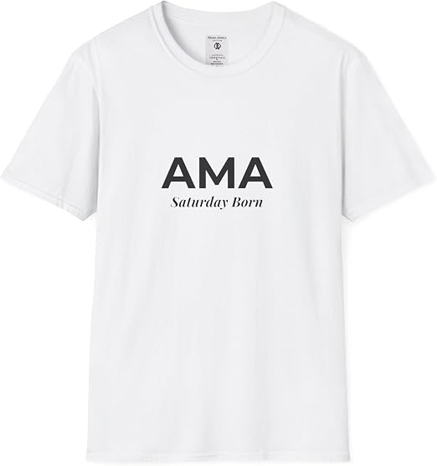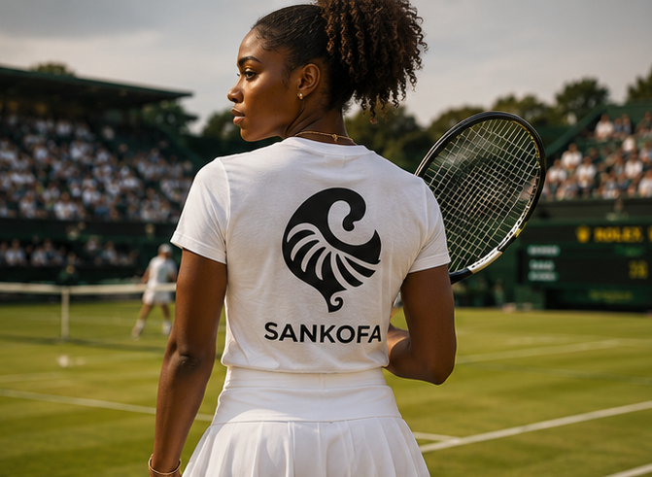
Ama Gye Nyame Back
https://www.amazon.com/dp/B0H3SDZ5T5?th=1&psc=1
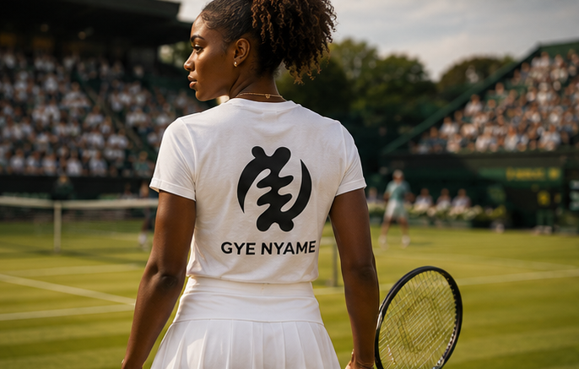
Kwame Gye Nyame
https://www.amazon.com/dp/B0H58WZVCH?th=1&psc=1
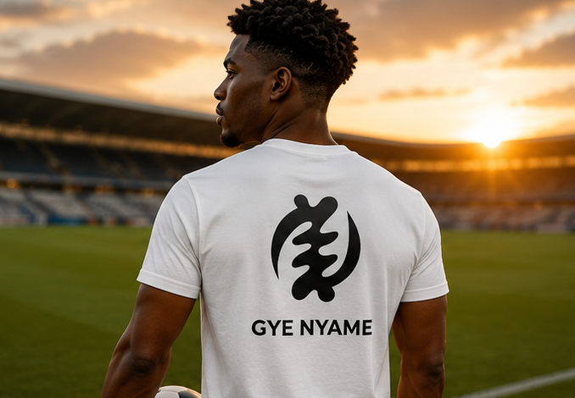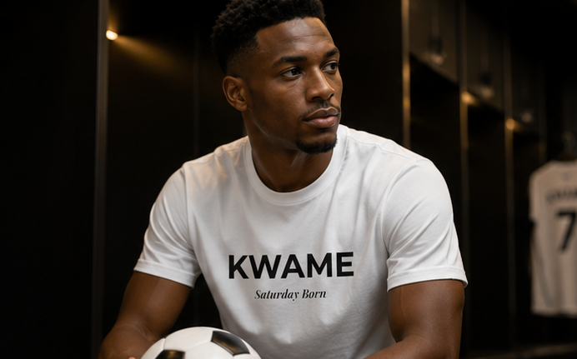

Kwame Sankofa Back
https://www.amazon.com/dp/B0H3SKZBHR?th=1&psc=1
